|  |  |  |  |
| --- | --- | --- | --- |
| **Project Name** | Hexacopter 2017 | **Date** | 04/03/17 |
| **Document Name** | Hexacopter Raspberry Manual | **Version** | 0.1.0 |
| **Date Created** | 11/03/17 |  |  |
| **Last Modified** | 12/03/17 | | |

Contents

Raspberry Pi 2 1

Booting 1

MicroUSB AC Adapter 1

Barrel Connector AC Adapter 1

Battery 1

Pi Desktop Environment 1

Wifi 2

PC to Pi 2

Pi to Internet 2

Wifi Router 2

References 2

# Raspberry Pi 2

## Booting

### MicroUSB AC Adapter

* Connect microUSB AC adapter to pi
* Disconnect the red JXT connector that runs off the Pi GPIO port

This will prevent powering the ESCs from the Pi

### Barrel Connector AC Adapter

* Attach the barrel adapter to the battery port on the hexacopter
* Connect the AC Adapter to the barrel adpater
* ESCs will beep until the Radio is connected?

### Battery

* Ensure the red JXT connector that runs of the Pi GPIO port is connected
* Ensure that the battery is charged and connect to main lead of the hexacopter

## Pi Desktop Environment

connect the HDMI port to a monitor and attach USB keyboard and mouse, then power the raspberry pi on.

After booting, use command /etc/init.d/lxdm start to start LXDE, or startx

## Backups

<https://thepihut.com/blogs/raspberry-pi-tutorials/17789160-backing-up-and-restoring-your-raspberry-pis-sd-card>

## Wifi

### PC to Pi

Connection to the ground is normally performed using the TPLINK wireless router, the gateway IP address should be 192.168.1.1,

If not, try connecting to windows via wifi or Ethernet and using ipconfig to get the gateway IP address.

On the router page, the IP

Password???

### Pi to Internet

Not sure, try:

1. Connect Ethernet port to a university internet outlet.
   1. Detects the connection, but no internet access
   2. Opening the browser will bring up a Netgear connection page.
2. Connect a USB wireless adapter to the Pi
   1. Try these threads:
      1. <http://raspberrypi.stackexchange.com/questions/47538/wlan-connected-but-no-internet-access>

## From DJI Manifold

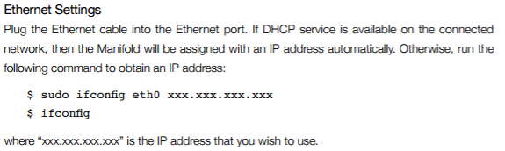

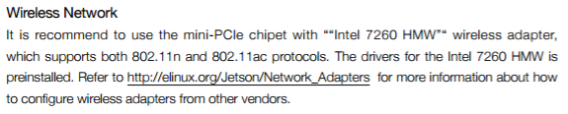 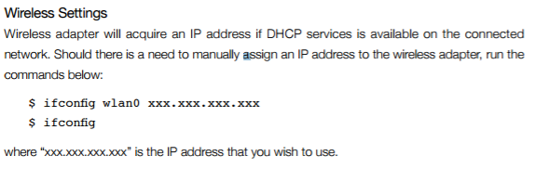

## Wifi Router

TPLINK WR703N

5V 1A

Running OpenWRT

SSID: OpenWrt

Gateway IP: 192.168.1.1

# References

|  |  |
| --- | --- |
| [1] | M. Mohanty, “Environmental Mapping in 2D/3D,” 2015. [Online]. Available: http://robotics.ee.uwa.edu.au/theses/2015-Hexacopter3D-Mohanty.pdf. |
| [2] | J. Tan, “picopterx,” [Online]. Available: https://github.com/jtanx/picopterx/wiki/. |
| [3] | J. Tan, “Real time point of interest identification,” 26 October 2015. [Online]. Available: http://robotics.ee.uwa.edu.au/theses/2015-HexacopterVision-Tan.pdf. |